“GROUP-DNA -- Your WhatsApp Group Chat, Decoded”

“A WhatsApp Group Analytics and Personality Detection System using Python”

GitHub Repository:
https://github.com/pataneniruthwik/GroupDNA.git

Abstract:
Group DNA is a Python-based mini project that analyses an exported WhatsApp chat file and generates useful insights about the group's messaging activity. The program reads the chat file, separates normal and system messages, performs participant, date, and hour-wise analysis, counts deleted and media messages, assigns personality archetypes, and provides a message lookup feature using date and time. This project demonstrates the practical use of Python fundamentals such as file handling, lists, dictionaries, loops, conditions, and string manipulation.

Objective:
- To read and analyse an exported WhatsApp chat file.
- To generate useful statistics about group activity.
- To perform participant, date, and hour-wise analysis.
- To count deleted and media messages.
- To assign personality archetypes based on user activity.
- To provide a message lookup feature using date and time.

Problem Statement:

Analysing large WhatsApp chats manually is difficult and time-consuming. The objective of this project is to develop a beginner-friendly Python application that automatically processes an exported chat file and generates meaningful insights about participant activity, messaging patterns, and group behaviours in a simple and readable report.

Workflow:

START
↓
Open Chat File
↓
Read All Lines
↓
Extract Date, Time, Sender and Message
↓
Separate Normal Messages and System Messages
↓
Group Overview
↓
Participant Analysis
↓
Activity Analysis
↓
Date Analysis
↓
Message Analysis
↓
Personality Archetypes
↓
Message Lookup
↓
Display Final Report
↓
END

Python Concepts Used:

- File Handling
- Lists
- Dictionaries
- Loops
- Conditional Statements
- String Functions (split(), strip(), lower())
- Dictionary Methods (items(), get())
- Built-in Functions (len(), max(), min())
- User Input (input())

Program Code:

# Step 1 - Open the chat file
file = open("chat.txt", "r")

# Step 2 - Read all lines
lines = file.readlines()

# Step 3 - Close the file
file.close()

print("====================================================")
print(" GROUPDNA REPORT")
print(" Your WhatsApp Group Chat, Decoded")
print("====================================================")

# Lists to store chat and system messages
messages = []
system_messages = []

# Process each line
for line in lines:

line = line.strip()

# Split into Date-Time and Remaining Part
parts = line.split(" - ")

# Skip incorrect line format
if len(parts) < 2:
continue

date_time = parts[0]
remaining = parts[1]

# Split Date and Time
date, time = date_time.split(", ")

# Check whether it is a normal chat message
if ": " in remaining:

# Split Sender and Message
sender, message = remaining.split(": ", 1)

# Store normal chat message
chat = {
"date": date,
"time": time,
"sender": sender,
"message": message
}

messages.append(chat)

else:

# Store system message
system = {
"date": date,
"time": time,
"event": remaining
}

system_messages.append(system)

# Group Overview
print("\n========== GROUP OVERVIEW ==========\n")

print("Total Chat Messages :", len(messages))
print("Total System Messages :", len(system_messages))
print("Total Entries :", len(messages) + len(system_messages))

# Participant Analysis
print("\n========== PARTICIPANT ANALYSIS ==========\n")

# Dictionary to count messages of each participant
member_count = {}

# Read every stored chat message
for chat in messages:

sender = chat["sender"]

# If sender already exists, increase the count
if sender in member_count:
member_count[sender] += 1

# Otherwise create a new sender entry
else:
member_count[sender] = 1

# Display message count of every participant
for sender, count in member_count.items():
print(sender, ":", count)

# Display total number of participants
print("\nTotal Participants :", len(member_count))

# Find most active participant
most_active = max(member_count, key=member_count.get)

print("Most Active Member :", most_active)
print("Messages Sent :", member_count[most_active])

# Find least active participant
least_active = min(member_count, key=member_count.get)

print("Least Active Member:", least_active)
print("Messages Sent :", member_count[least_active])
# Activity Analysis
print("\n========== ACTIVITY ANALYSIS ==========\n")

# Dictionary to count messages by hour
hour_count = {}

# Read every stored chat message
for chat in messages:

hour = chat["time"].split(":")[0]

# If hour already exists, increase the count
if hour in hour_count:
hour_count[hour] += 1

# Otherwise create a new hour entry
else:
hour_count[hour] = 1

# Display message count of every hour
for hour, count in hour_count.items():
print(hour, ":", count)
# Find most active hour
most_active_hour = max(hour_count, key=hour_count.get)

print("\nMost Active Hour :", most_active_hour)
print("Messages Sent :", hour_count[most_active_hour])

# Find least active hour
least_active_hour = min(hour_count, key=hour_count.get)

print("\nLeast Active Hour :", least_active_hour)
print("Messages Sent :", hour_count[least_active_hour])

# Date Analysis
print("\n========== DATE ANALYSIS ==========\n")

# Dictionary to count messages by date
date_count = {}

# Read every stored chat message
for chat in messages:

date = chat["date"]

# If date already exists, increase the count
if date in date_count:
date_count[date] += 1

# Otherwise create a new date entry
else:
date_count[date] = 1

# Display message count of every date
for date, count in date_count.items():
print(date, ":", count)

# Find most active date
most_active_date = max(date_count, key=date_count.get)

print("\nMost Active Date :", most_active_date)
print("Messages Sent :", date_count[most_active_date])

# Find least active date
least_active_date = min(date_count, key=date_count.get)

print("\nLeast Active Date :", least_active_date)
print("Messages Sent :", date_count[least_active_date])
# Message Analysis
print("\n========== MESSAGE ANALYSIS ==========\n")

deleted_count = 0
media_count = 0

# Read every stored chat message
for chat in messages:

message = chat["message"]

# Count deleted messages
if "deleted" in message.lower():
deleted_count += 1

# Count media messages
if "<media omitted>" in message.lower():
media_count += 1

print("Deleted Messages :", deleted_count)
print("Media Messages :", media_count)
# Personality Analysis
print("\n========== PERSONALITY ARCHETYPES ==========\n")
# Dictionary to store persona of each participant
persona = {}

for sender, count in member_count.items():
# Check every participant
# Assign personality archetype
if count >= 500:
persona[sender] = "THE SPAMMER"
print("Persona :", persona[sender])
elif count >= 200:
persona[sender] = "THE SOCIAL BUTTERFLY"
print("Persona :", persona[sender])

elif count >= 50:
persona[sender] = "THE STORYTELLER"
print("Persona :", persona[sender])

else:
persona[sender] = "THE GHOST"
print("Persona :", persona[sender])

# Search Message by Date and Time
print("\n========== SEARCH MESSAGE ==========\n")

choice = input("Do you want to search a message? (yes/no): ")

if choice.lower() == "yes":

search_date = input("Enter Date (dd/mm/yy): ")
search_time = input("Enter Time (hh:mm): ")

found = False

# Search every stored chat message
for chat in messages:

if chat["date"] == search_date and chat["time"] == search_time:

print("\nMessage Found")
print("Sender :", chat["sender"])
print("Persona :", persona[chat["sender"]])
print("Message :", chat["message"])

found = True
break

if found == False:
print("\nNo message found.")

else:
print("\nThank You!")

Sample Output:

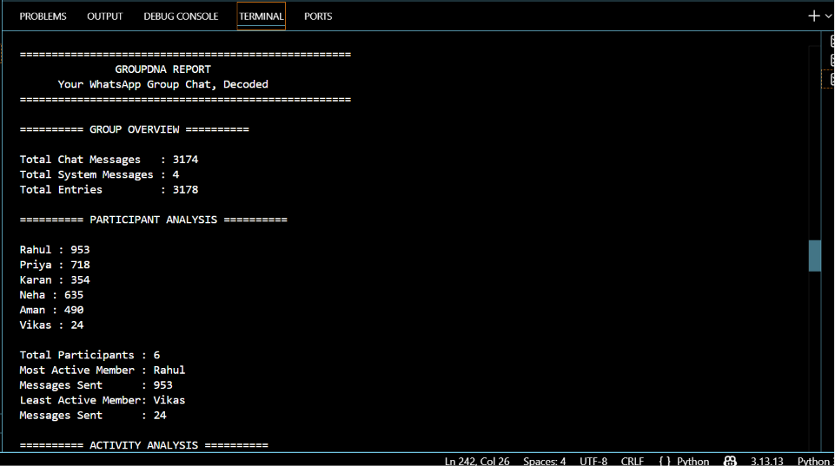

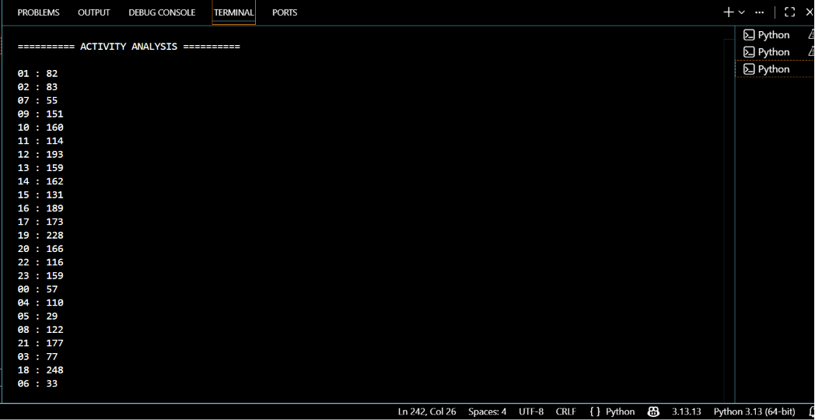

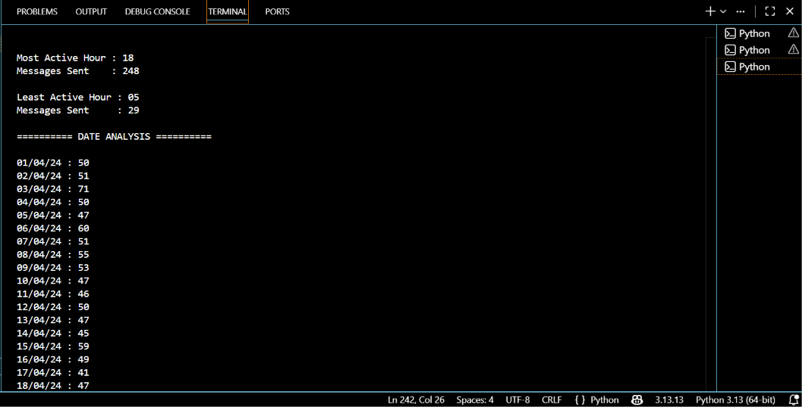

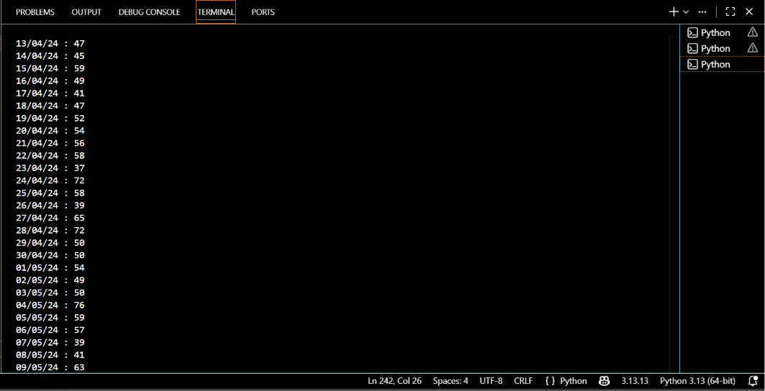

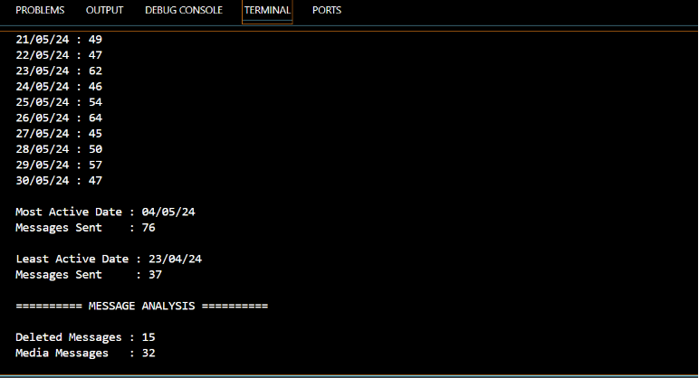

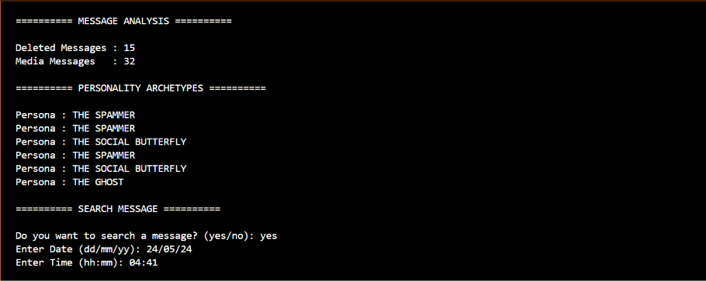

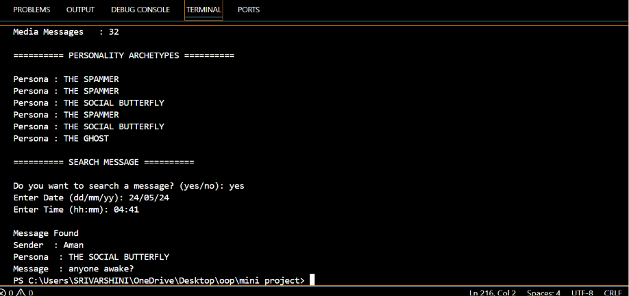

Conclusion:

Group DNA successfully analyses an exported WhatsApp chat and generates meaningful insights about group conversations. The program performs participant, activity, date, and message analysis, detects personality archetypes, and presents the results in a simple and organized report. In addition to the core features, the project also includes a bonus Message Lookup feature, which allows users to search for a message using its date and time and displays the sender along with their detected persona. Overall, this project demonstrates the effective application of Python fundamentals such as file handling, string manipulation, lists, dictionaries, loops, and conditional statements to solve a real-world problem in a beginner-friendly manner.

THANK YOU

